AI-Powered Anomaly Detection in Image-Guided Surgeries
1. Problem Statement
Image-guided surgeries rely heavily on human expertise to detect anomalies such as tumors, misalignments, or distortions. Current approaches are prone to fatigue-induced errors, lack real-time feedback, and offer limited explainability—posing risks to patient safety.

2. Clinical Needs
Surgeons require more than simple anomaly detection. Key requirements include:
- Localization of anomalies within organ structures
- Visual evidence for immediate validation
- Confidence scoring to gauge reliability
- Concise, automated reports for decision support

3. Proposed Solution
A real-time, explainable AI pipeline integrating:
- CNN-based segmentation for organ delineation (liver, initially)
- Diffusion models (DDPM + DDIM) for reconstructing healthy anatomy
- Residual heatmaps to highlight deviations
- Traffic-light scoring system for intuitive alerts
- Automated clinical reporting to summarize findings

4. Pipeline Workflow
Step | Description
1 | Preprocess input CT slice
2 | Segment liver using CNN
3 | Reconstruct healthy slice with DDIM
4 | Generate residual heatmap (input vs reconstruction)
5 | Score anomalies with traffic-light system
6 | Auto-generate structured report
7 | Display original slice, reconstruction, heatmap, and report

5. Model Architecture
Task | Model | Notes
Liver Segmentation | CNN (U-Net) | Lightweight, trained on chaos
Healthy Reconstruction | DDPM + DDIM | Unsupervised diffusion model for anomaly detection
Anomaly Localization | Residual Heatmap | Pixel-wise difference highlights abnormal regions
Anomaly Scoring | Rule-based | Green/Yellow/Red based on heatmap intensity
Reporting | Agentic AI | Structured clinical summaries generated automatically

6. System Block Diagram
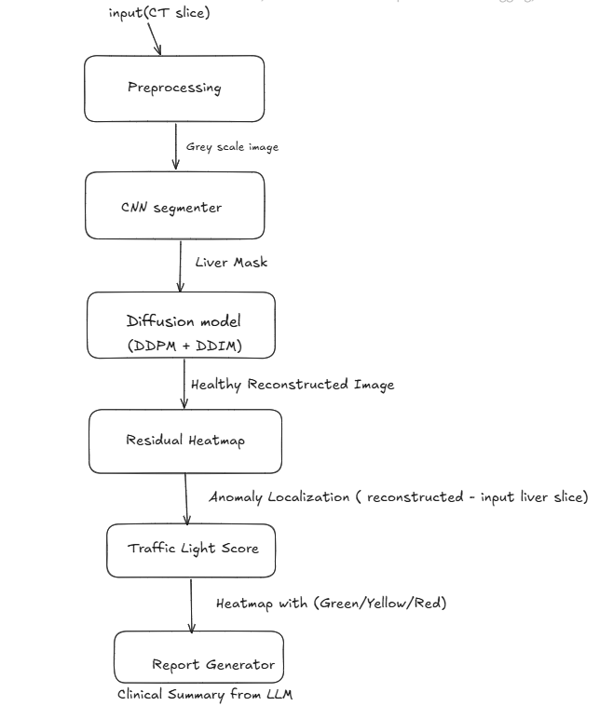

7. Advantages
- Label-efficient: Unsupervised learning reduces dependency on annotated datasets
- Explainable: Heatmaps and traffic-light scoring make anomalies interpretable
- Actionable: Structured reports support faster clinical decision-making
- Real-time capable: Lightweight models allow near-instant feedback

8. Feasibility
- Public datasets (CHAOS) available for training
- Modular architecture supports seamless hospital integration
- Lightweight design enables real-time inference

9. Future Enhancements
- Expand to multi-organ detection (lungs, brain, spine)
- Extend to 3D volumetric anomaly mapping
- Integrate with PACS and hospital EMR systems
- Upgrade to foundation models for generalizable detection
- Incorporate semi-supervised learning with expert feedback

